Basic Linux Commands Homework – Marko Mihajlov

1. Create a file friends.txt with a list of names of three of your friends on separate lines.



Running ls to confirm file creation.

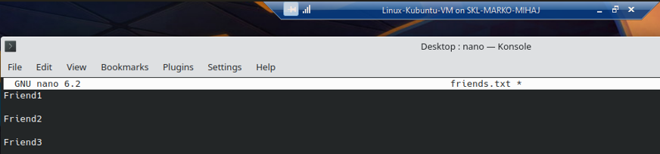

Write contents of file, save with Ctrl + O then press enter. Exit with Ctrl + X.

2. Display the contents of friends.txt on the console.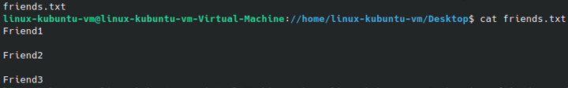

3. Rename file friends.txt to bestfriends.txt



Running ls again afterwards to confirm the performed change.

4. Make a copy of bestfriends.txt under the name sysadmins.txt



Running ls again to confirm file copy with different name in the same location.

5. List all files whose name begins with letter 'b' and ends with extension txt.

The star symbol (\*) is used as a wildcard – meaning all letters after b are accepted and ending with .txt

6. Write a command that will tell you how many bytes are taken up by file sysadmins.txt



Used command du – read the flag to be used -b from running du –help which lists the command line utility’s options.

7. Create file cars.txt with a list of 5 brands of cars on separate lines.



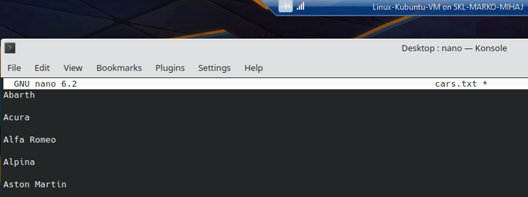

Write contents of file, save with Ctrl + O then press enter. Exit with Ctrl + X.

8. Check how many bytes are taken up by the file.



Used command du – read the flag to be used -b from running du –help which lists the command line utility’s options.

9. Copy the file cars.txt into directory /tmp



Copying using current directory to copy from (file cars.txt) and using absolute path to paste starting from root and pasting into tmp directory.

10. List all files with extension \*.txt in directory /tmp and verify that the file was copied properly.



We can go into temp dir and list locally or better from where we started from using absolute path using the ls command with the whole path included and listing all .txt files with the wildcard \*



Used diff- compare files line by line (CMD Utility) – if there are no differences, nothing is listed. On the other hand if there are it lists the whole rows with differences by default.

11. Without leaving your home directory rename file cars.txt located in /tmp to vehicles.txt in /tmp



Using absolute path to go to /tmp and change the filename of cars to vehicles. I am always using absolute rather than relative path to avoid making mistakes by not exactly writing the correlation to the current path. Also using ls to confirm name change.

12. Display the contents of /etc/passwd file on the screen interactively (so you can search, scroll up and down)



Using the less command line utility with which we can list files interactively and search through them.

Able to move through file if window is small enough. Commands for moving or searching available at less –help or man less.

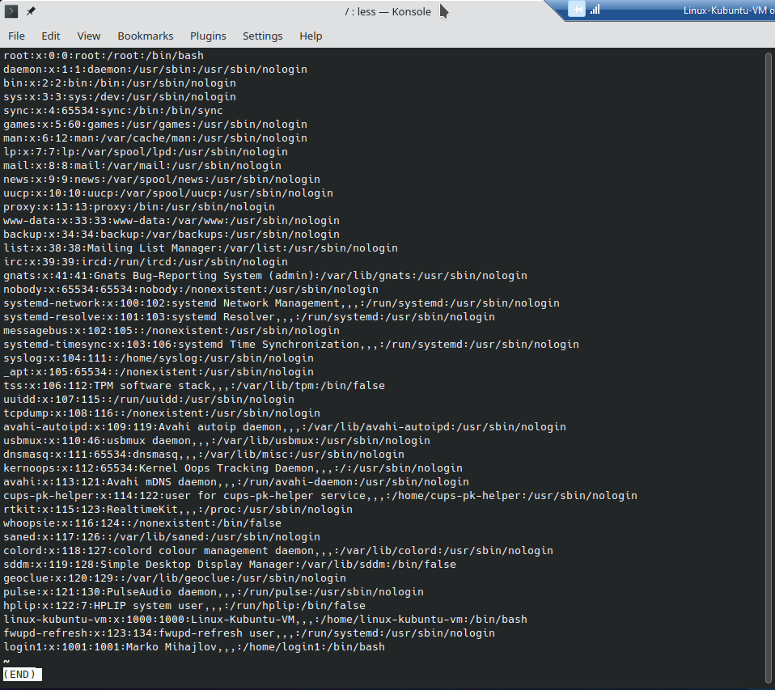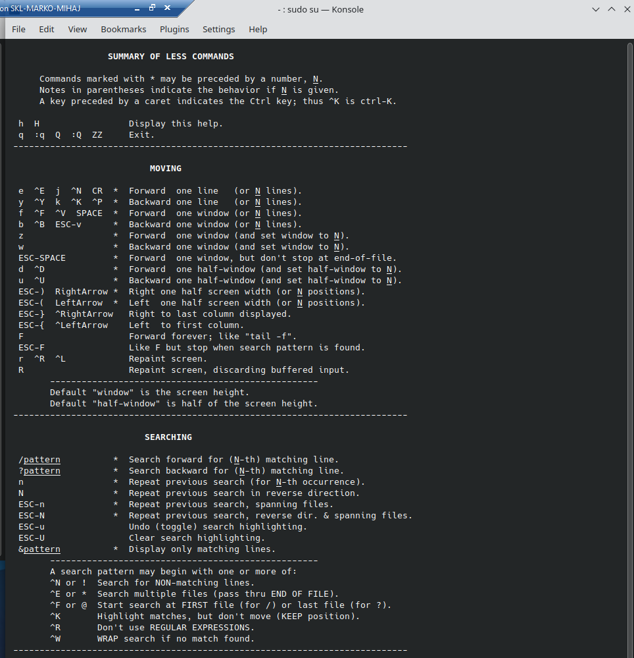

End of file.